**STORAGE GATEWAY**

Hybridge storage concept in AWS is storage gateway

On-premises storage is private storage and AWS is public storage is public

combination of private and public storage is called Storage Gateway

It is used to synchronizing data from on-premises to AWS

Storage gateway should be on on-premises (Appliance)

we will get the image from AWS and download the image and setup in on- premises

storage gateway is mediator between on-premises and AWS

AWS Storage Gateway is a service connecting an on-premises software appliance with cloud-based storage to provide seamless and secure integration between an organization's on-premises IT environment and AWS storage infrastructure.

The service enables you to store data securely on the AWS cloud in a scalable and cost-effective manner. AWS Storage Gateway supports industry-standard storage protocols that work with your existing applications.

It provides low-latency performance by caching frequently accessed data

on premises while encrypting and storing all of your data in Amazon S3 or Amazon Glacier.

SG

**ON-PREMISES**

2TB/8TB ..etc

**STORAGE GATE WAY**

within the storage gateways family there are 3 different types of gateways

* **File Gateways:** File Gateway enables you to store and retrieve objects in S3 using file protocols such as **NFS or SMB (Server Message Block)**

Files written to the File Gateway can be directly accessed in AWS as S3 objects or on-premises as files.

Block storage in Amazon S3 with point-in-time backups as Amazon EBS snapshots.

2 types of gateways

* **cache volume:** low latency, and frequently accessed data
* **stored volume:** don’t want to frequently accessed data then we can use stored volume
* **Tape Gateway:** Back up your data to Amazon S3 and archive in Amazon S3 Glacier using your existing tape-based processes.

Physical back up (Virtual Tape Library)

On-Prem 🡪 VTL 🡪 Glacier (AWS)

* **Volume Gateway:** Volume Gateway provides Cloud back block storage to application using iSCSI protocol

Data on the volumes is stored in S3, and can be backed up as Amazon EBS snapshots in the cloud

* **Amazon FSx File Gateway**

Low-latecny on-primised access to fully managed, highly reliabl, and virtually unlimited windies files shares provided by Amazon FSx Windows File Server.

**Key benefits of using Storage Gateway**

* Storage gateway supports multiples storage protocols enabling you to seamlessly connect on-premises application to AWS Storage without having to modify those applications.
* Storage gateway also supports a fully managed local cache, which provides low latency access to frequently used data.
* Storage gateway also supports data transfers, which are optimized flight
* Storage gateway compresses the data before synchronizing data to cloud and it also fetches only the data that’s needed when data requested is not in the cache. This helps speed up data transfer, and optimize response time to application I/O
* with Storage gateway, only pay for what you use and elastically scale storage as your on-premises workload grow.
* finally, gateways deployed on-premises are managed monitored and updated from the cloud simplifying management.

**Storage Gateway-LAB**

1. Create Storage Gateway on EC2 (Choose File Gateway)

2. Launch EC2 instance with **m4. Xlarge** having root volume **80GB** and add volume with **100GB**

3. Enable ALL TRAFFIC for default SG(Temporary)

4. Connect to the Gateway: Provide EC2 instance public IP to active (in real time use EIP)

5. Wait until to get the gateway active and allocate additional 100GB volume as Cache

6. Create a bucket(private)

7. Create a file share from Storage Gateway Console, and provide S3 bucket details and allow 0.0.0.0/0 all client to connect to the share

(In real time, restrict network who should connect to files share)

8. Launch Redhat EC2 instance t2.micro

sudo yum intall -y nfs-utils

mkdir <<directory-name>>

mkdir filegateway --> any directory

mount -t nfs -0 nolock.hard 172.31.16.225:/storagegatewaybkt filegateway/

cd filegateway

Create sample files and check in S3

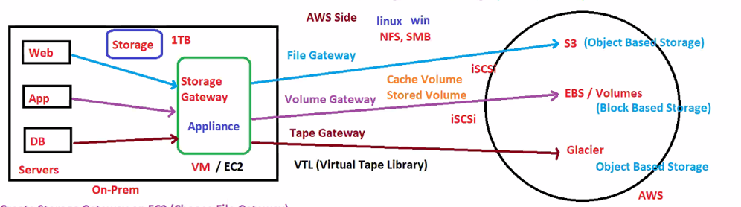

1.Select Gateway type

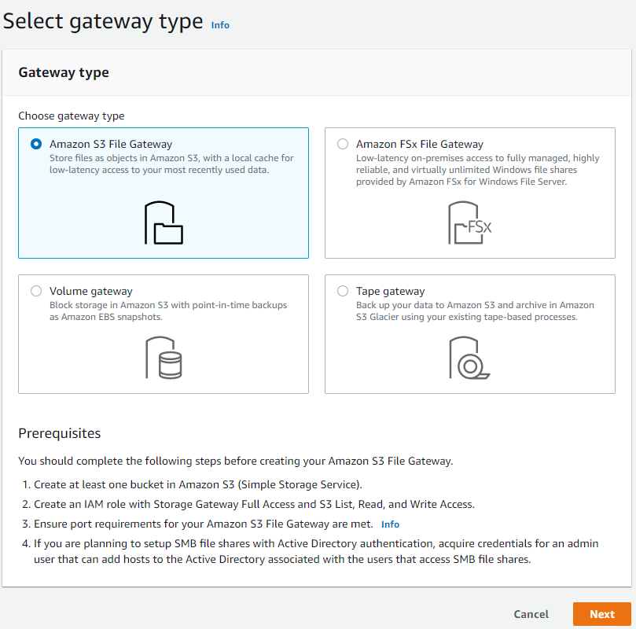

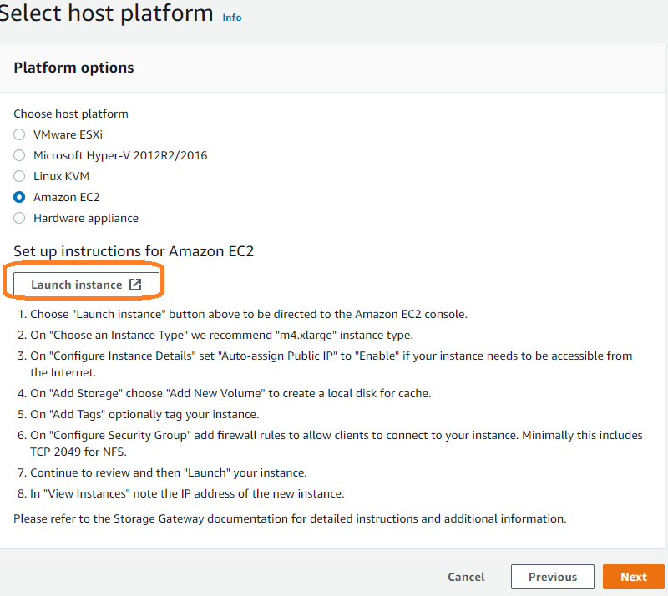

EC2 instance will be ready with instance type m4.xlarge

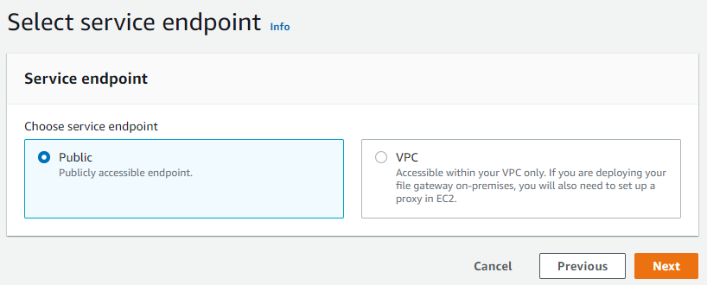

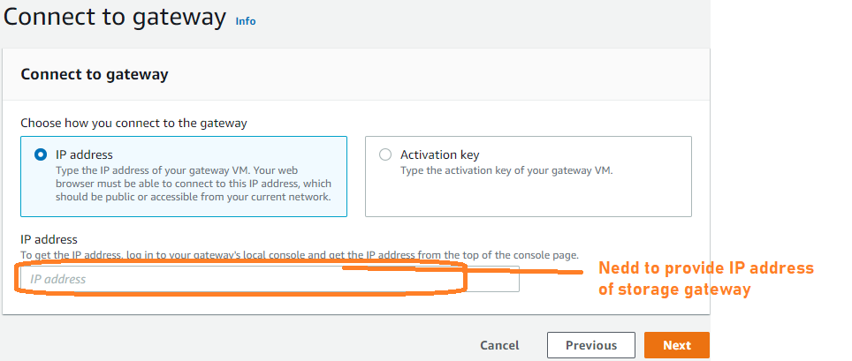

Provide the Gateway name and activate.

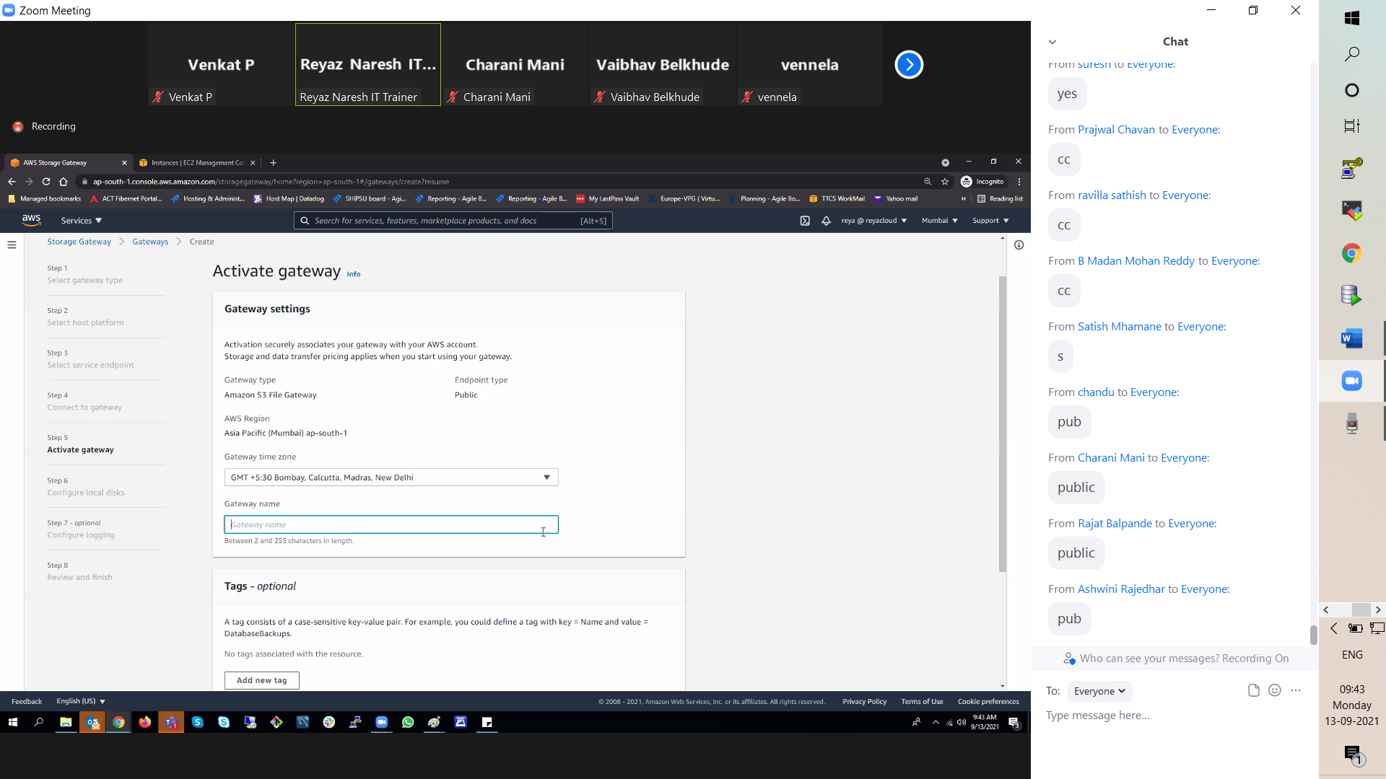

Preparing local disk i.e additional disk storage details

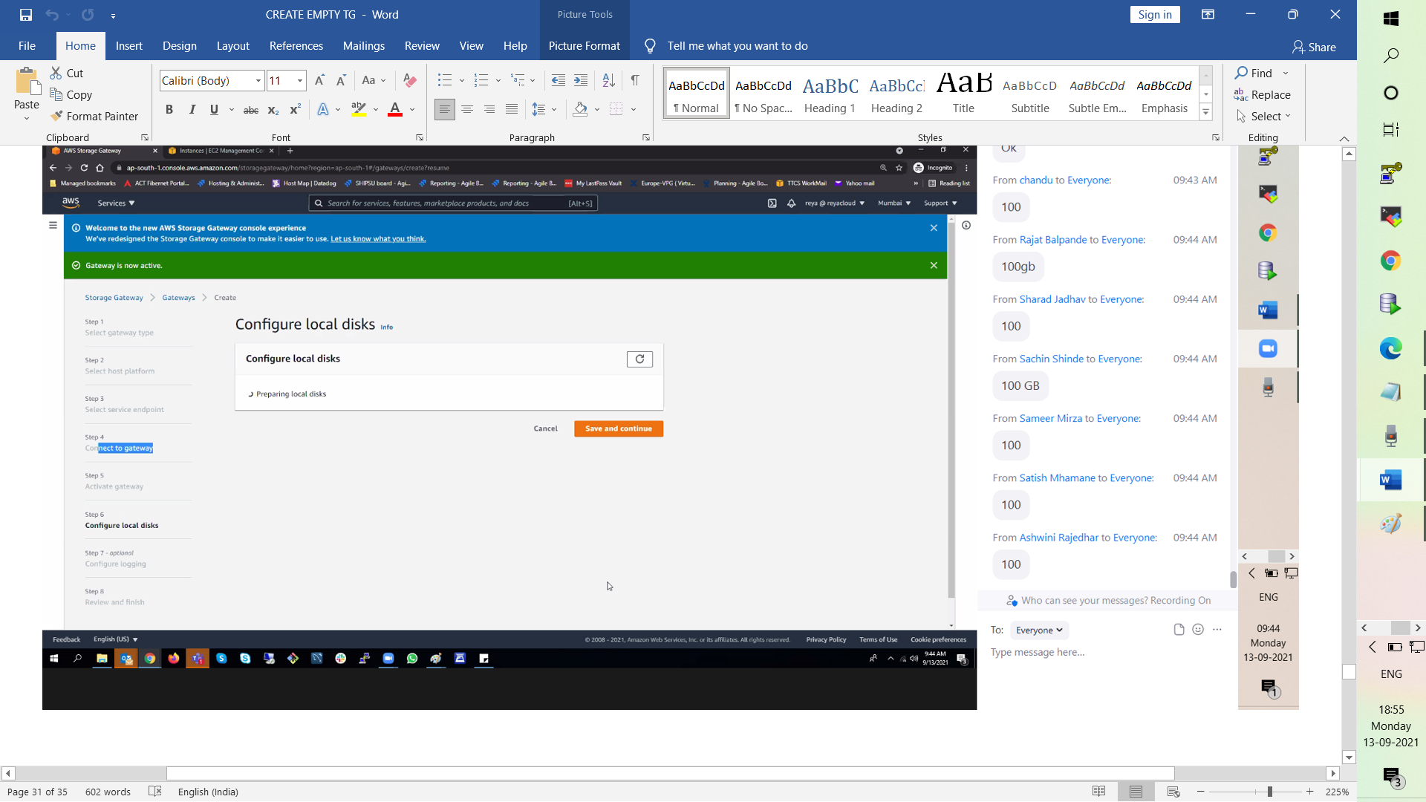

Creating S3 bucket

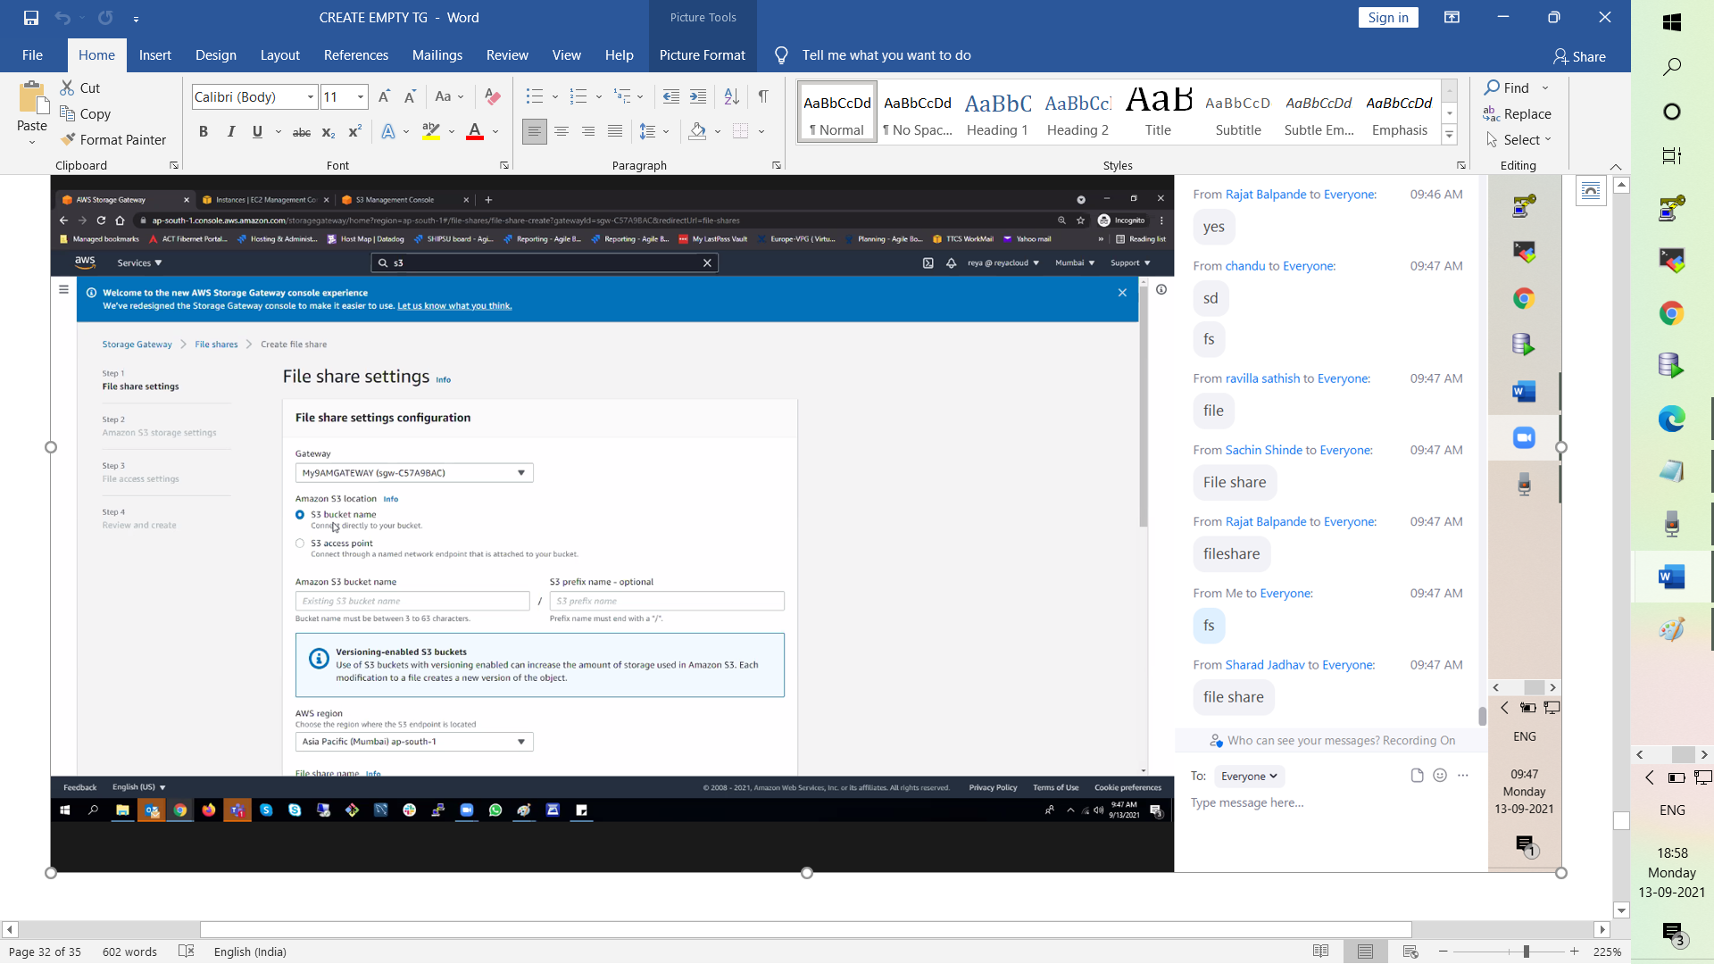

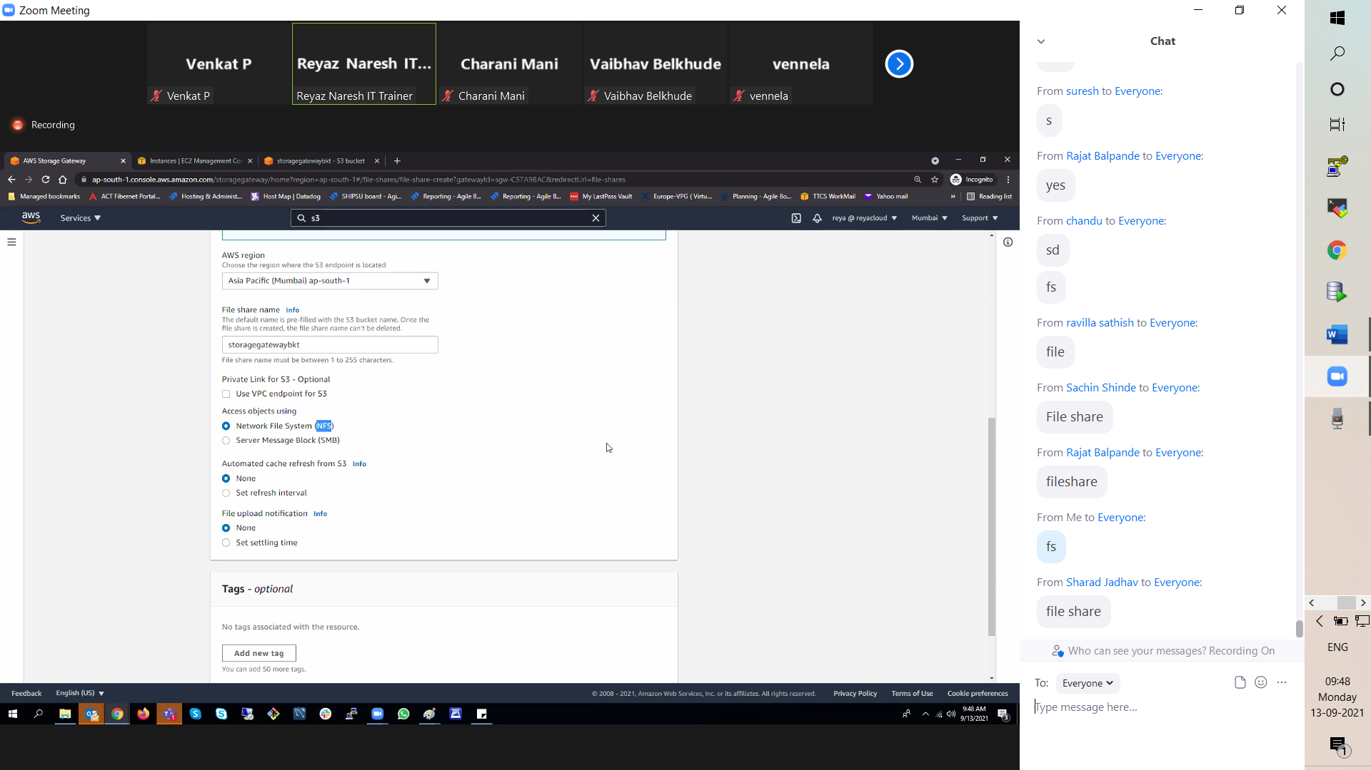

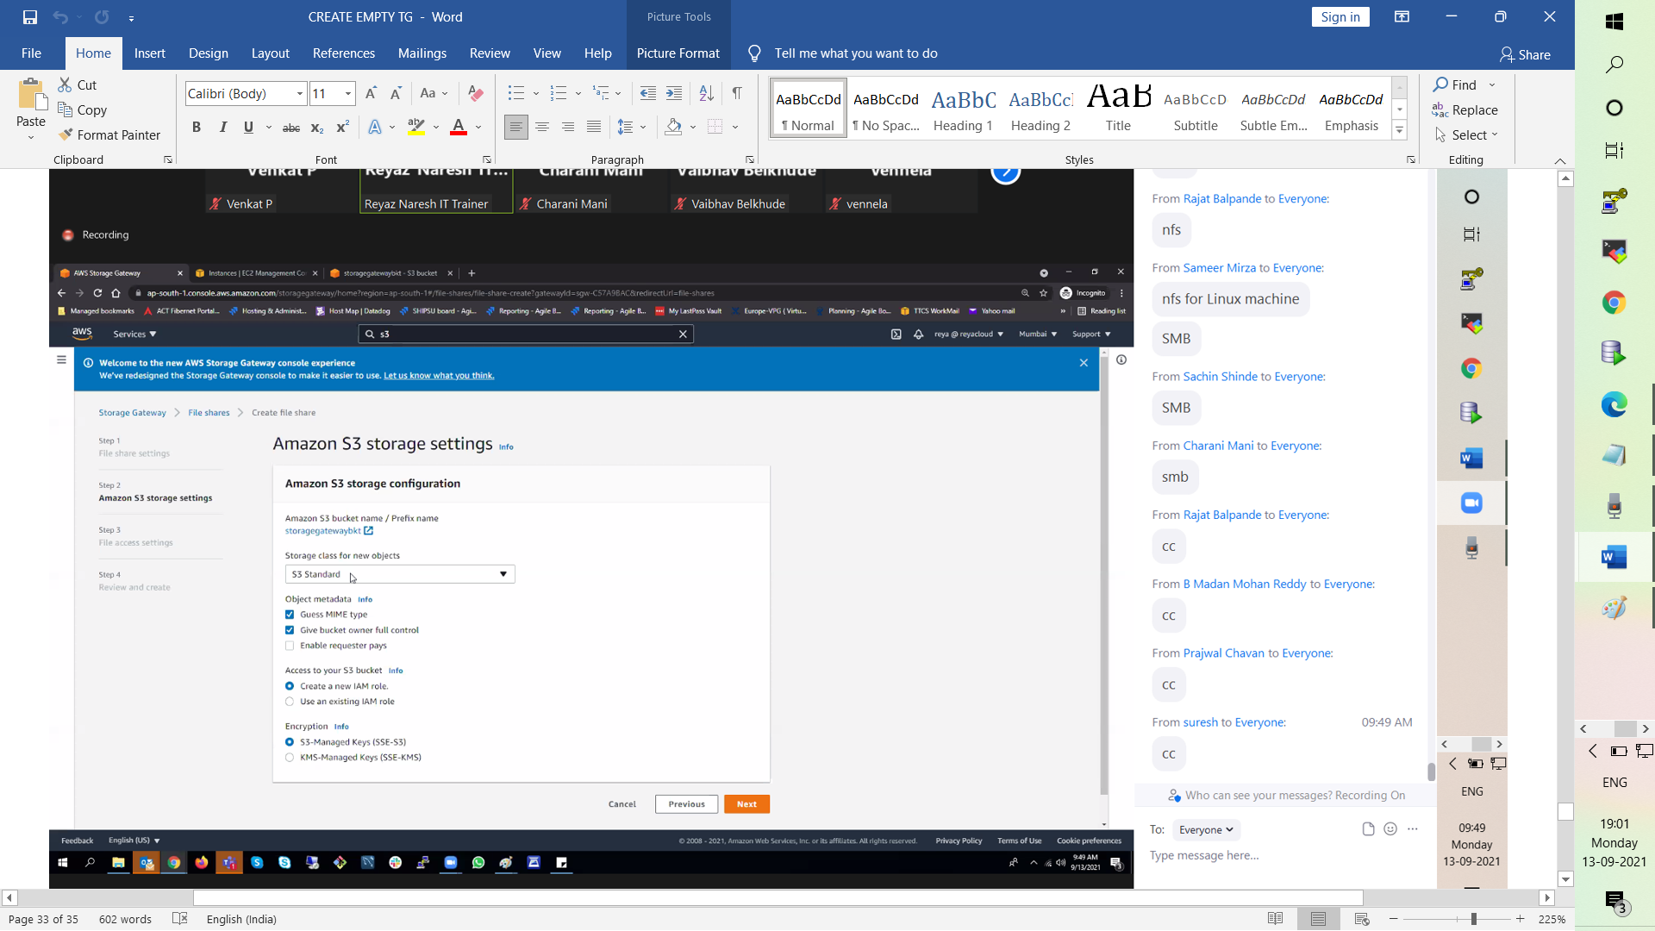

Which network machine to connect storage gateway ( 0.0.0.0/0) all client to connet file share

